**CONFIGURING MULTI AREA OPEN SHORTEST PATH FIRST LAB**

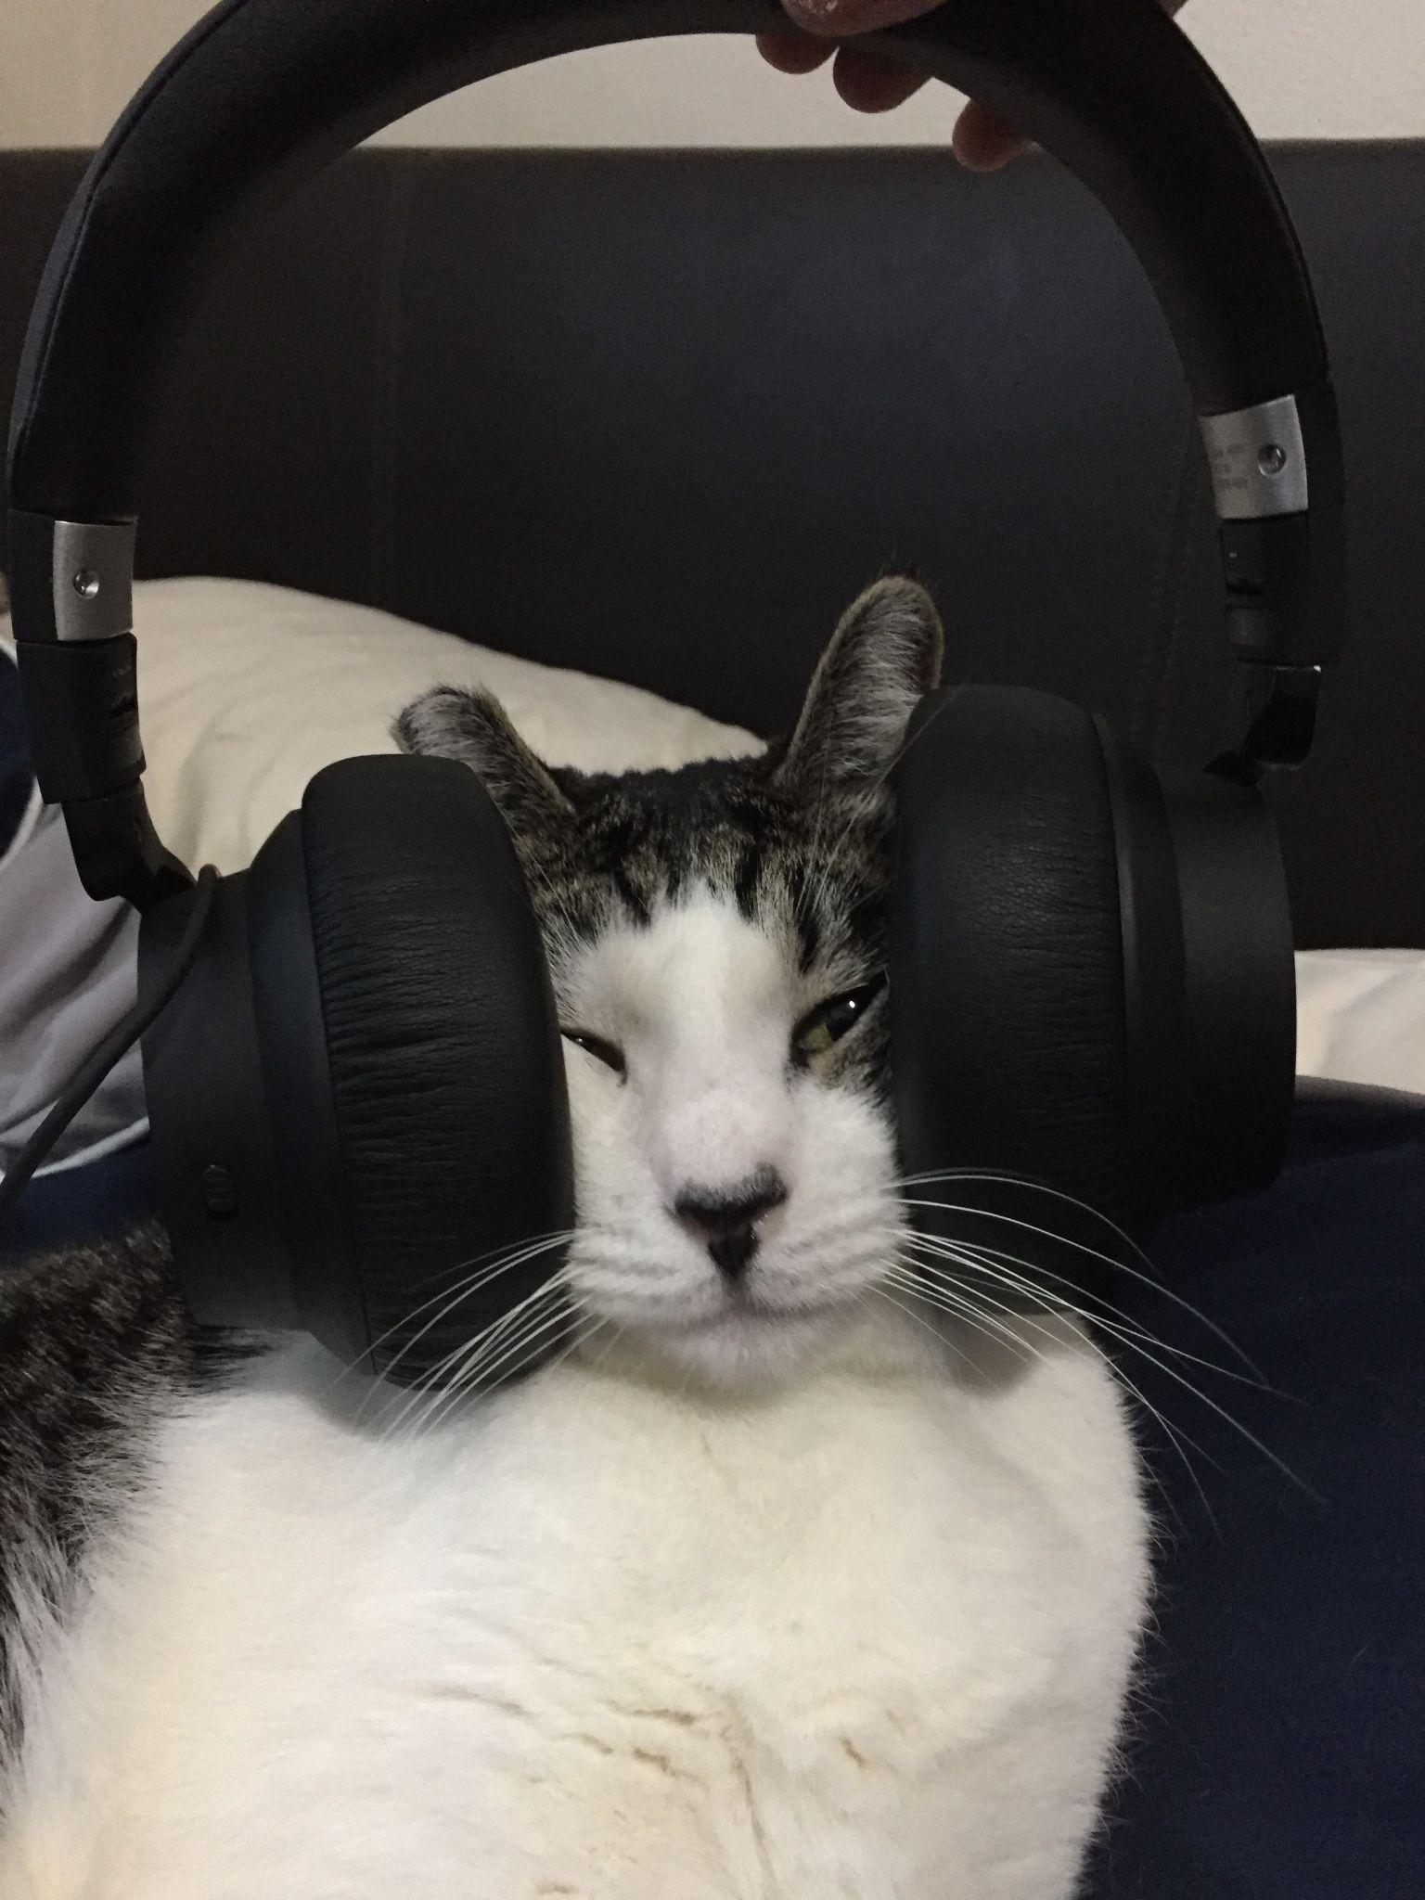

***BY: ALEKSIE SANCHEZ MEDEIROS***



***Purpose***

To learn how to configure multi area OSPFv2 and OSPFv3 connectivity among 6 point-to-point routers on a network.

***Background***

OSPF is an interior routing protocol which uses link-state routing to determine the best possible route for a packet to go through in order to reach its destination on a network. OSPF is used as an alternative to traditional manual routing which requires the network administrator to manually configure individual routes. OSPF is also a better alternative than the old distance-vector routing protocols which suffered from multiple issues with scalability and reliability.  
  
 Multi Area OSPF is a more complex structure of OSPF where the network is divided into different areas to avoid a large influx of packets constantly sending hello messages while attempting to build their routing tables across a network with multiple routers. Using Multi Area OSPF requires dividing the network into different sections, which in the case of this lab are area 0, area 1 and area 2. The numbers which may seem superfluous are actually important in the configuration of multi area OSPF. Specifically, area 0 is used as a backbone area, the backbone area is what creates the routing topology that will be given to other routers in other areas. This is configured as such in order to decrease convergence time and avoid any additional delays if a route were to disappear. In addition all traffic that is headed from one area to another must pass through the backbone area. This is done to diminish the risk of looping packets on the network when dealing with inter area packets.

***Lab summary***

At the end of the lab, IPV4 and IPv6 connect between two PCs on opposite ends of 6 point-to-point routers using multi area OSPFv2 and OSPFv3 between all the routers without requiring manual configuration from a network administrator.

***Lab Commands***

***ip ospf 1 area [area number] -*** is utilized to tell the interface that it should be using the first OSPF process and should be communicating with other routes using the same area. Its role changes if it's using area 0 or the backbone area.

***ipv6 ospf 1 area [area number] -*** is similar to ***router ospf 1*** but instead used for IPv6 and it does not require writing the networks that should be advertised and needs a unique router-id.

***network [network address] [wildcard mask] area [area number] -*** used inside the OSPF instance to tell what network and subnet should be advertised to the rest of the routers participating in OSPF. The area portion is dependent on what area that router should be participating in.

***Network Diagram***

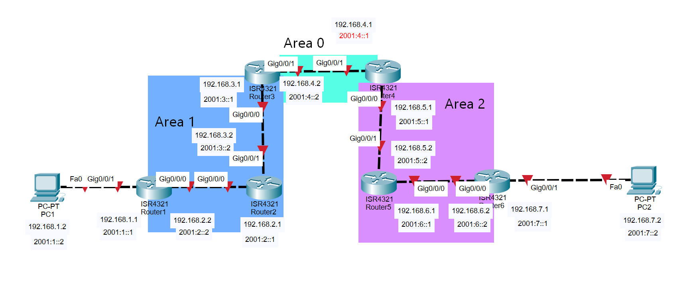

***Router Configurations***

***R1:***

**Last configuration change at 21:45:14 UTC Mon Oct 10 2022**

**version 15.5**

**service timestamps debug datetime msec**

**service timestamps log datetime msec**

**no platform punt-keepalive disable-kernel-core**

**hostname R1**

**boot-start-marker**

**boot-end-marker**

**vrf definition Mgmt-intf**

**address-family ipv4**

**exit-address-family**

**address-family ipv6**

**Exit-address-family**

**no aaa new-model**

**no ip domain lookup**

**ipv6 unicast-routing**

**subscriber templating**

**multilink bundle-name authenticated**

**license udi pid ISR4321/K9 sn FDO21482HZX**

**spanning-tree extend system-id**

**redundancy**

**mode none**

**vlan internal allocation policy ascending**

**interface GigabitEthernet0/0/0**

**ip address 192.168.2.2 255.255.255.0**

**ip ospf 1 area 1**

**negotiation auto**

**ipv6 address 2001:2::2/64**

**ipv6 ospf 1 area 1**

**interface GigabitEthernet0/0/1**

**ip address 192.168.1.1 255.255.255.0**

**ip ospf 1 area 1**

**negotiation auto**

**ipv6 address 2001:1::1/64**

**ipv6 ospf 1 area 1**

**interface Serial0/1/0**

**interface Serial0/1/1**

**interface GigabitEthernet0**

**vrf forwarding Mgmt-intf**

**no ip address**

**shutdown**

**negotiation auto**

**interface Vlan1**

**no ip address**

**shutdown**

**router ospf 1**

**network 192.168.1.0 0.0.0.255 area 1**

**network 192.168.2.0 0.0.0.255 area 1**

**ip forward-protocol nd**

**no ip http server**

**no ip http secure-server**

**ip tftp source-interface GigabitEthernet0**

**ipv6 router ospf 1**

**router-id 1.1.1.1**

**control-plane**

**line con 0**

**stopbits 1**

**line aux 0**

**stopbits 1**

**line vty 0 4**

**login**

**end**

***R2:***

**Last configuration change at 21:54:00 UTC Mon Oct 10 2022**

**version 15.5**

**service timestamps debug datetime msec**

**service timestamps log datetime msec**

**no platform punt-keepalive disable-kernel-core**

**hostname R2**

**Boot-start-marker**

**boot-end-marker**

**vrf definition Mgmt-intf**

**address-family ipv4**

**exit-address-family**

**address-family ipv6**

**exit-address-family**

**no aaa new-model**

**ipv6 unicast-routing**

**subscriber templating**

**multilink bundle-name authenticated**

**license udi pid ISR4321/K9 sn FDO21482DWJ**

**spanning-tree extend system-id**

**redundancy**

**mode none**

**vlan internal allocation policy ascending**

**interface GigabitEthernet0/0/0**

**ip address 192.168.2.1 255.255.255.0**

**ip ospf 1 area 1**

**negotiation auto**

**ipv6 address 2001:2::1/64**

**ipv6 ospf 1 area 1**

**interface GigabitEthernet0/0/1**

**ip address 192.168.3.2 255.255.255.0**

**ip ospf 1 area 1**

**negotiation auto**

**ipv6 address 2001:3::2/64**

**ipv6 ospf 1 area 1**

**interface Serial0/1/0**

**no ip address**

**shutdown**

**interface Serial0/1/1**

**no ip address**

**shutdown**

**interface GigabitEthernet0**

**vrf forwarding Mgmt-intf**

**no ip address**

**shutdown**

**negotiation auto**

**interface Vlan1**

**no ip address**

**shutdown**

**router ospf 1**

**network 192.168.2.0 0.0.0.255 area 1**

**network 192.168.3.0 0.0.0.255 area 1**

**ip forward-protocol nd**

**no ip http server**

**no ip http secure-server**

**ip tftp source-interface GigabitEthernet0**

**ipv6 router ospf 1**

**router-id 2.2.2.2**

**control-plane**

**line con 0**

**stopbits 1**

**line aux 0**

**stopbits 1**

**line vty 0 4**

**login**

**end**

***R3:***

**Last configuration change at 21:50:05 UTC Mon Oct 10 2022**

**version 15.5**

**service timestamps debug datetime msec**

**service timestamps log datetime msec**

**no platform punt-keepalive disable-kernel-core**

**hostname R3**

**boot-start-marker**

**boot-end-marker**

**vrf definition Mgmt-intf**

**address-family ipv4**

**exit-address-family**

**address-family ipv6**

**exit-address-family**

**no aaa new-model**

**ipv6 unicast-routing**

**subscriber templating**

**vtp domain cisco**

**vtp mode transparent**

**multilink bundle-name authenticated**

**license udi pid ISR4321/K9 sn FDO214420HW**

**spanning-tree extend system-id**

**redundancy**

**mode none**

**vlan internal allocation policy ascending**

**interface GigabitEthernet0/0/0**

**ip address 192.168.3.1 255.255.255.0**

**negotiation auto**

**ipv6 address 2001:3::1/64**

**ipv6 ospf 1 area 1**

**interface GigabitEthernet0/0/1**

**ip address 192.168.4.2 255.255.255.0**

**negotiation auto**

**ipv6 address 2001:4::2/64**

**ipv6 ospf 1 area 0**

**interface Serial0/1/0**

**no ip address**

**shutdown**

**interface Serial0/1/1**

**no ip address**

**shutdown**

**interface GigabitEthernet0**

**vrf forwarding Mgmt-intf**

**no ip address**

**shutdown**

**negotiation auto**

**interface Vlan1**

**no ip address**

**shutdown**

**router ospf 1**

**network 192.168.3.0 0.0.0.255 area 1**

**network 192.168.4.0 0.0.0.255 area 0**

**ip forward-protocol nd**

**no ip http server**

**no ip http secure-server**

**ip tftp source-interface GigabitEthernet0**

**ipv6 router ospf 1**

**router-id 3.3.3.3**

**control-plane**

**line con 0**

**stopbits 1**

**line aux 0**

**stopbits 1**

**line vty 0 4**

**login**

**end**

***R4:***

**Last configuration change at 21:28:42 UTC Mon Oct 10 2022**

**version 15.5**

**service timestamps debug datetime msec**

**service timestamps log datetime msec**

**no platform punt-keepalive disable-kernel-core**

**hostname R4**

**boot-start-marker**

**boot-end-marker**

**vrf definition Mgmt-intf**

**address-family ipv4**

**exit-address-family**

**address-family ipv6**

**exit-address-family**

**no aaa new-model**

**ipv6 unicast-routing**

**subscriber templating**

**vtp domain cisco**

**vtp mode transparent**

**multilink bundle-name authenticated**

**license udi pid ISR4321/K9 sn FDO214421D1**

**spanning-tree extend system-id**

**redundancy**

**mode none**

**vlan internal allocation policy ascending**

**interface GigabitEthernet0/0/0**

**ip address 192.168.5.1 255.255.255.0**

**negotiation auto**

**ipv6 address 2001:5::1/64**

**ipv6 ospf 1 area 2**

**interface GigabitEthernet0/0/1**

**ip address 192.168.4.1 255.255.255.0**

**negotiation auto**

**ipv6 address 2001:4::1/64**

**ipv6 ospf 1 area 0**

**interface Serial0/1/0**

**no ip address**

**shutdown**

**interface Serial0/1/1**

**no ip address**

**shutdown**

**interface GigabitEthernet0**

**vrf forwarding Mgmt-intf**

**no ip address**

**shutdown**

**negotiation auto**

**interface Vlan1**

**no ip address**

**shutdown**

**router ospf 1**

**network 192.168.4.0 0.0.0.255 area 0**

**network 192.168.5.0 0.0.0.255 area 2**

**ip forward-protocol nd**

**no ip http server**

**no ip http secure-server**

**ip tftp source-interface GigabitEthernet0**

**ipv6 router ospf 1**

**router-id 4.4.4.4**

**control-plane**

**line con 0**

**stopbits 1**

**line aux 0**

**stopbits 1**

**line vty 0 4**

**login**

**end**

***R5:***

**Last configuration change at 23:19:28 UTC Mon Oct 10 2022**

**version 16.9**

**service timestamps debug datetime msec**

**service timestamps log datetime msec**

**platform qfp utilization monitor load 80**

**no platform punt-keepalive disable-kernel-core**

**hostname R5**

**boot-start-marker**

**boot-end-marker**

**vrf definition Mgmt-intf**

**address-family ipv4**

**exit-address-family**

**address-family ipv6**

**exit-address-family**

**no aaa new-model**

**ip dhcp pool webuidhcp**

**subscriber templating**

**vtp domain cisco**

**vtp mode transparent**

**ipv6 unicast-routing**

**multilink bundle-name authenticated**

**crypto pki trustpoint TP-self-signed-859896477**

**enrollment selfsigned**

**subject-name cn=IOS-Self-Signed-Certificate-859896477**

**revocation-check none**

**rsakeypair TP-self-signed-859896477**

**crypto pki certificate chain TP-self-signed-859896477**

**certificate self-signed 01**

**3082032E 30820216 A0030201 02020101 300D0609 2A864886 F70D0101 05050030**

**30312E30 2C060355 04031325 494F532D 53656C66 2D536967 6E65642D 43657274**

**69666963 6174652D 38353938 39363437 37301E17 0D323231 30313032 30343031**

**365A170D 33303031 30313030 30303030 5A303031 2E302C06 03550403 1325494F**

**532D5365 6C662D53 69676E65 642D4365 72746966 69636174 652D3835 39383936**

**34373730 82012230 0D06092A 864886F7 0D010101 05000382 010F0030 82010A02**

**82010100 E03C144F 32999B8A 96F1EAE4 BF5890B4 2D6A0FBC BC903879 91FCB8D5**

**1DC9F763 89A3359E 9A4DABF2 AC2F357E 15E62BBC 44FB7686 B241DBA9 50087FD4**

**6E0478F7 D7F980F2 32B7D23F 40B30880 8ECD15CD E1A7CB63 6CAF3A80 063C954E**

**E2B3CBE3 F704AD95 41CE9FA9 393D4546 5A23739D D0EC5198 6FEBF6B9 14BD742D**

**9EAEB971 56B27C9D EBDA9577 80071249 5736F348 4EF3C08B 569F2A40 37115D68**

**E444348F 2F1E955B 4A7165E9 95720FF3 774D8E2C 3EAEC312 40A177ED 49A3F37A**

**7864D398 5BC0069D ACA5E9BF 779D4A33 3CA0F153 92539439 376D007C 4E5A3469**

**4D131DEC 5547E1A4 6E2549F6 D3022C20 6010973D AFF97AC0 5E034015 30CCA7C0**

**62D8E6B1 02030100 01A35330 51300F06 03551D13 0101FF04 05300301 01FF301F**

**0603551D 23041830 1680140A 64F404BF 6B67C0FE 240702BC 77D85CB0 D2267330**

**1D060355 1D0E0416 04140A64 F404BF6B 67C0FE24 0702BC77 D85CB0D2 2673300D**

**06092A86 4886F70D 01010505 00038201 010033B3 D9DC0ED9 12580F8F E6326504**

**7BA59DB0 A0E94214 5F75B709 4F9A4D33 3CDBA9AF EE70C666 B16CAA89 F12520C9**

**D25E6E1A E5EEF8FA B218B1CA BA07DB4B F32B8F26 55297C00 4F27E475 147244E5**

**E8823BA1 DDF1F5A5 EE03841B 361F4C09 074DEFE1 B31A9554 31A41343 526F39A9**

**DC94AB67 DDBD7444 A04C57DD F588021A A8F56FC2 9A259C82 933A705E 93A959CE**

**FC8EE8D4 68057572 BD5C61A2 12E47681 391D18DF C0721709 F4C7D4B0 6515105E**

**5E618A6B 5BDD01E4 1A0951CF 6B1C0201 AE80F7FA AF83B04F 04C69419 9C4DD61E**

**87E4FA02 B159AA99 B8F597FB 34263979 3C980899 8D977837 03AE1C3E 239E4B8B**

**2011AF58 2532723C 42DAFFB7 E13EC52A 005E**

**quit**

**license udi pid ISR4321/K9 sn FLM240608PJ**

**no license smart enable**

**diagnostic bootup level minimal**

**spanning-tree extend system-id**

**redundancy**

**mode none**

**interface GigabitEthernet0/0/0**

**ip address 192.168.6.1 255.255.255.0**

**ip ospf 1 area 2**

**negotiation auto**

**ipv6 address 2001:6::1/64**

**ipv6 enable**

**interface GigabitEthernet0/0/1**

**ip address 192.168.5.2 255.255.255.0**

**ip ospf 1 area 2**

**negotiation auto**

**ipv6 address 2001:5::2/64**

**ipv6 enable**

**interface GigabitEthernet0/1/0**

**no ip address**

**shutdown**

**negotiation auto**

**interface GigabitEthernet0/1/1**

**no ip address**

**shutdown**

**negotiation auto**

**interface GigabitEthernet0**

**vrf forwarding Mgmt-intf**

**no ip address**

**shutdown**

**negotiation auto**

**router ospf 1**

**network 192.168.5.0 0.0.0.255 area 2**

**network 192.168.6.0 0.0.0.255 area 2**

**ip forward-protocol nd**

**ip http server**

**ip http authentication local**

**ip http secure-server**

**ip tftp source-interface GigabitEthernet0**

**control-plane**

**line con 0**

**transport input none**

**stopbits 1**

**line aux 0**

**stopbits 1**

**line vty 0 4**

**login**

**end**

***R6:***

**Last configuration change at 21:40:38 UTC Mon Oct 10 2022**

**version 16.9**

**service timestamps debug datetime msec**

**service timestamps log datetime msec**

**platform qfp utilization monitor load 80**

**platform punt-keepalive disable-kernel-core**

**hostname R6**

**boot-start-marker**

**boot-end-marker**

**vrf definition Mgmt-intf**

**address-family ipv4**

**exit-address-family**

**address-family ipv6**

**exit-address-family**

**no aaa new-model**

**login on-success log**

**subscriber templating**

**ipv6 unicast-routing**

**multilink bundle-name authenticated**

**crypto pki trustpoint TP-self-signed-4288135047**

**enrollment selfsigned**

**subject-name cn=IOS-Self-Signed-Certificate-4288135047**

**revocation-check none**

**rsakeypair TP-self-signed-4288135047**

**crypto pki certificate chain TP-self-signed-4288135047**

**certificate self-signed 01**

**30820330 30820218 A0030201 02020101 300D0609 2A864886 F70D0101 05050030**

**31312F30 2D060355 04031326 494F532D 53656C66 2D536967 6E65642D 43657274**

**69666963 6174652D 34323838 31333530 3437301E 170D3232 31303130 32303336**

**31345A17 0D333030 31303130 30303030 305A3031 312F302D 06035504 03132649**

**4F532D53 656C662D 5369676E 65642D43 65727469 66696361 74652D34 32383831**

**33353034 37308201 22300D06 092A8648 86F70D01 01010500 0382010F 00308201**

**0A028201 0100DDE7 B7298D9F 1E2AF6E9 11B693FE 22247488 02DF0E64 62C40C23**

**C31B9C9A 30B18869 7605F30A 29B75F0E 5FCCA081 D13B0E40 9324E842 D1C54A9F**

**EF0F2067 982188BA 826AC6A4 BD8C2A6E 4A8B9D11 DEF432AC 038DB408 0E2B6328**

**A3EA611B 59B79F1F DAD49B48 9D7E9F4D 42305376 345638BF 5D70AE6F 3C89D261**

**3E983CF2 6D05CA11 FACA18C3 14515A90 C681695A 02065FF1 A349C2DB 09E07505**

**46C59F36 1541B53D 1E969DF2 98AEDB53 9CF5DAEC 572F91DA 71147243 3C38000B**

**9D0EBF91 1A83374C 8CFC84FB C900DB9D E3BAB146 ADF8EB72 304A2E87 1316DF54**

**53682655 980655F7 FCB59C55 2817A6FF BC069F7C C8AD041F 03AD912B B576E566**

**26331ECE 9E970203 010001A3 53305130 0F060355 1D130101 FF040530 030101FF**

**301F0603 551D2304 18301680 14F4ED6F DC032123 84AFF8BF CCFEFC13 F8640062**

**5F301D06 03551D0E 04160414 F4ED6FDC 03212384 AFF8BFCC FEFC13F8 6400625F**

**300D0609 2A864886 F70D0101 05050003 82010100 C9C7BBB5 1065DB03 E21794AA**

**87E34A32 88E9FD24 61EF4B4F CDAD3F98 AC84DEA3 DA77F59F 0453B942 6CC166DC**

**2A9F0525 4465A5BE F96B5AC2 457F5EDA CE0DAB17 E28F06E0 42D0A183 BC9AAC28**

**65B896BC 0AE733B6 E34910CD 58773EF4 2911575D 98FDB119 881BCEBA 3670D4B8**

**995ED3D6 1CB04754 9F04FFB8 BBD85C1E F1F9E807 8D64EA9B C3F1D075 AC08196A**

**8D2BD212 7BE7A306 7C8FCF46 ACD4906B BBDA0D7C A0D0DFC1 4D63AB41 B00F322A**

**E01D7926 3B0FC8EF BF1DEAEB 8081F1C5 FC5B9B19 92652EE5 73570173 F7692D92**

**330557B8 4FD295CB 66A5AEAD B87FFA4C 01A83205 E1739546 0F1EF646 B21D6E86**

**F86CACE8 C18C9127 1B9E88AB 336E9B00 9596E09A**

**quit**

**license udi pid ISR4321/K9 sn FLM2406090M**

**no license smart enable**

**diagnostic bootup level minimal**

**spanning-tree extend system-id**

**redundancy**

**mode none**

**interface GigabitEthernet0/0/0**

**ip address 192.168.6.2 255.255.255.0**

**ip ospf 1 area 2**

**negotiation auto**

**ipv6 address 2001:6::2/64**

**ipv6 ospf 1 area 2**

**interface GigabitEthernet0/0/1**

**ip address 192.168.7.1 255.255.255.0**

**ip ospf 1 area 2**

**negotiation auto**

**ipv6 address 2001:7::1/64**

**ipv6 ospf 1 area 2**

**interface GigabitEthernet0/1/0**

**no ip address**

**shutdown**

**negotiation auto**

**interface GigabitEthernet0/1/1**

**no ip address**

**shutdown**

**negotiation auto**

**interface GigabitEthernet0**

**vrf forwarding Mgmt-intf**

**no ip address**

**shutdown**

**negotiation auto**

**router ospf 1**

**network 192.168.6.0 0.0.0.255 area 2**

**network 192.168.7.0 0.0.0.255 area 2**

**ip forward-protocol nd**

**ip http server**

**ip http authentication local**

**ip http secure-server**

**ip tftp source-interface GigabitEthernet0**

**ipv6 router ospf 1**

**router-id 6.6.6.6**

**control-plane**

**line con 0**

**transport input none**

**stopbits 1**

**line aux 0**

**stopbits 1**

**line vty 0 4**

**Login**

**end**

***Screenshots***

*Shown below is the entire routing table of R1, this tells R1 where to send each packet entering R1; note the different letters next to each entry that state where each route was created. In this case, the IA next to the O for OSPF, tells the router that it comes from outside its current OSPF area.*

*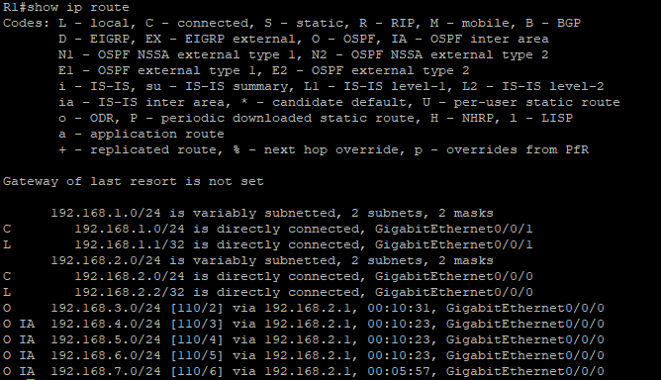  
Shown below is a picture of an IPv6 traceroute from PC 1 to Router 6, in this case the default gateway of PC2, completed to test IPv6 connectivity across the network.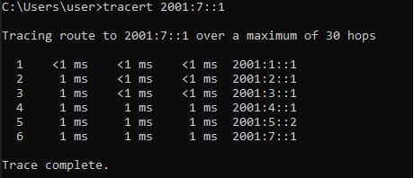  
Shown below is a picture of a traceroute from PC 1 to Router 6, in this case the default gateway of PC2, completed to test connectivity across the network*

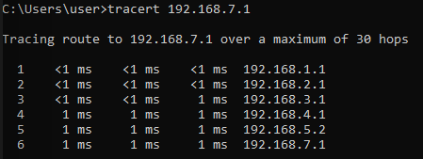

***Problems***

As I started an investigation on how Multi Area OSPF should be set up in a network, I had forgotten about how Multi Area OSPF uses a hierarchy topology, where area 0 is used for Inter Area routing and its importance in a complete network convergence. As a result of this, our network would not send any packets from area 1 towards area 2. Our solution was to change our area numbers on the network configuration towards proper configuration of Multi Area OSPF.  
  
 Then we had run into our largest issue with Multi Area OSPFv3, where the other routers would not learn anything from R5 to the PC on the other end of the point-to-point network and where R5 would not learn IPv6 OSPF routes from other areas. At first I thought it was an issue with how inter area IPv6 was configured, so I reconfigured OSPFv3 from the beginning again on the routers. As a final attempt I tried copying the configuration on a different set of routers and the configuration worked. As it turned out, the differing versions between Router 4 and Router 5 were causing an issue where IPv6 multi area OSPF routes would not be shared. In order to solve this issue, I would have to ensure that all the routers were on the same version and thus avoid further version errors. To do this I set up a TFTP server using TFTPd64 and got the .bin file of the router with the newest version. Then I copied the file from the config onto the router and used the boot system command to apply the new IOS. This fixed the issue and allowed the routers to advertise their OSPFv3 routes.

***Conclusion***

In summary, I learnt about the technical issues that are sometimes caused by having differing versions between routers, and how to set up TFTP servers off Windows machines, I also gained a better understanding as to how versions might cause issues in communication. I also learnt about some of the technicalities from Multi Area OSPF such as how important the backbone area is for the general support of the network.